|  |
| --- |
| EE495/CME495 |
| Robotic Positioner System Design Document |
| Revision 1 |

|  |
| --- |
| Thomas Hu, Jordan Smith, Jason Wong  11-20-2019 |

Contents

1 Purpose 3

1.1 Scope 3

1.2 Document Organization 3

1.3 Document Identifier 3

1.4 Applicable Documents 3

1.5 Revision History 3

1.6 Abbreviations and Acronyms 3

2 System Design Description 4

2.1 General 4

2.2 System Description 4

2.2.1 Disconnect Box 5

2.2.2 Control Box 5

2.2.3 Control Panel 5

2.2.4 Rotator 5

3 Detailed Design 6

3.1 Hardware Deliverables 6

3.2 Control Box 6

3.3 Control Panel 6

3.4 Rotator 7

3.5 A Frames 7

3.6 Technical Specifications 7

4 System Operation 8

4.1 System Software 8

4.2 System Operations 8

4.2.1 User Inputs 9

4.2.2 Operator Feedback 9

4.2.3 Home Function 10

4.3 E-Stop Functionality 10

**Table of Figures**

Figure 1 - System Block Diagram 4

Figure 4‑1 - Software State Diagram 8

**Table of Tables**

Table 3‑1 - Hardware Deliverables Table 6

Table 3‑2 - System Specifications 7

Table 4‑1 - Behaviour of LED and Buzzer for each System State 9

# Purpose

This document is used to control the Doepker Industries Robot Positioner system design characteristics to ensure that the design complies with all the requirements of the CD3 – EE495/CME495 System Requirement Matrix document.

## Scope

This document addresses the physical, electrical, data, and functional aspects of the Doepker Industries Robot Positioner. It provides technical descriptions of the components and subsystems required to satisfy the requirements in the CD3 – EE495/CME495 System Requirement Matrix document.

## Document Organization

The following sections in this document are organized as follows:

* Section 2.0 provides information on the general design of the system. A brief description of each system component is provided.
* Section 3.0 provides detailed information on the system design. In-depth descriptions of each system component are provided, and technical information on the system is presented.
* Section 4.0 provides information on how the system is operated. Various system functionality is explored in this section.

## Document Identifier

This document is identified as:

**CD4 – EE495/CME495 System Design Document**

## Applicable Documents

Applicable documents include:

**CD3 – EE495/CME495 System Requirements Document**

## Revision History

|  |  |  |
| --- | --- | --- |
| **Date** | **Revision** | **Changes** |
| November 27, 2019 | 1 | Initial Revision |
|  |  |  |

## Abbreviations and Acronyms

|  |  |
| --- | --- |
| E-stop | Emergency stop |
| TBD | To be determined |

# System Design Description

## General

The Doepker Industries Robot Positioner is a welding positioner that is designed to continuously rotate a load using a motor. The rotator is capable of rotating a load of minimum 1000 lbs around the horizontal axis at small angular increments to assist the operator when they are required to weld an object at an awkward angle. The system is designed for safety and ease-of-operation and allows the operator to easily rotate the system to a “home” angle position. The system is built to be operated at the workshops of Doepker Industries.

Figure 1 shows a block diagram of the system. The Disconnect Box, Control Box, Control Panel, and Rotator subsystems will be introduced in more detail in this section. The detailed design for each subsystem will be presented in Section 3. The entire system, besides the Control Panel is mounted onto two “A” frames separated by a table to place the load on. FIGURE depicts the overall system.

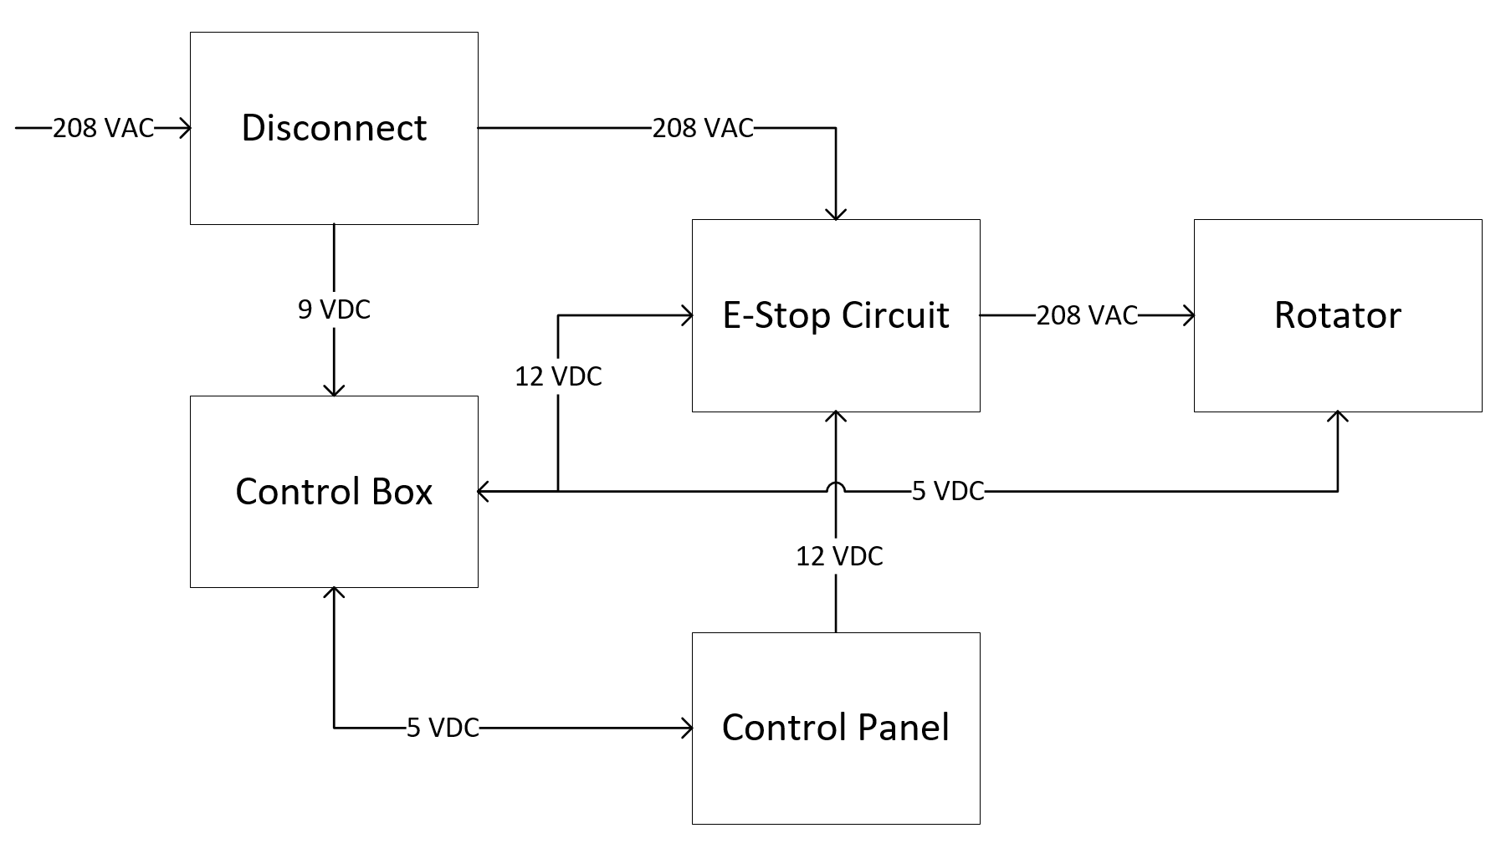

Figure 1 - System Block Diagram

## System Description

This section introduces the Disconnect Box, Control Box, Control Panel, and Rotator systems. This includes high-level descriptions of the hardware, main functionality, and interfacing.

### Disconnect Box

The disconnect box is a steel enclosure that allows 208 VAC input to pass through to the rotator. It also contains a power supply to supply DC voltage to the Control Box subsystem. It also contains power relays which are used by the system to prevent power from going to the rotator if the emergency stop is activated. The subsystem is designed to be attached to the system “A” frame.

### Control Box

The Control Box subsystem is a steel enclosure which contains the microcontroller. The Control Box performs the computing operations in the overall system by taking user input from the Control Panel and driving the motor in the Rotator. In addition, it features a power and calibration button, used to turn on/off and set a home button respectively. The box is physically connected to each subsystem. The box takes 9 VDC input and distributes 5 VDC output to the Rotator and 5 VDC to the Control Panel. It also takes 12 VDC input from the E-Stop Circuit to monitor if an E-stop is engaged in the system. The Control Box is mounted onto the primary “A” frame of the system.

### Control Panel

The Control Panel subsystem is used by the operator to control the system. It provides the operator with the ability to perform all system rotation operations. The panel is mounted onto a stand, which is connected to the system by a 10ft long flexible cord used to power the Panel and send user inputs to the Control Box. The panel itself is a steel enclosure with an assortment of buttons and switches on the front which are used to operate the system. The Control Panel is powered by 5 VDC supplied by the Control Box.

### Rotator

The Rotator consists of a motor, encoder, and a slew drive. The motor used is a servo motor, which is attached to an encoder. The encoder provides closed loop feedback signals to provide speed/position information to the microcontroller in the Control Box. The slew drive is used to step down the motor’s speed of rotation, simultaneously increasing the torque to high enough levels to rotate and attached load. The output shaft of the slew drive will interface with a welding table provided by the client. These components are mounted to the top of the “A” frame.

# Detailed Design

The purpose of this section is to discuss in detail the hardware design of the system. The design of the Control Box, Control Panel, and Rotator will be explored here.

## Hardware Deliverables

System components were chosen with the intention that the system shall be operated in a temperature-controlled environment between 0°C to 35°C. All system components are RoHS compliant. Table 3‑1 shows the list of hardware deliverables for one Robotic Rotator unit:

|  |  |  |  |
| --- | --- | --- | --- |
| Manufacturer | Item | Quantity | Comments |
| Arduino | Uno Microprocessor |  |  |
|  |  |  |  |
|  |  |  |  |

Table 3‑1 - Hardware Deliverables Table

## Control Box

The Control Box is a steel enclosure which contains the Arduino Uno microcontroller and E-stop circuit. It is mounted onto the primary frame and can be easily detached using standard tools. The front of the enclosure may be opened for maintenance procedures, which may include reprogramming the microcontroller or replacing any components.

There are power and calibration buttons located on the side of the box, which are used to turn on/off the system and set a “home” position which can be easily rotated to from any angle using the Control Panel.

The Arduino Uno board is based on the ATmega328P microcontroller. It can perform all the computing required to operate the system using the onboard I/O pins. The pins are used to receive user input from the Control Panel and Control Box, and to drive the motor in the Rotator. It is programmed with the system software, which regulates the timing and duration of which the table will be rotated. Finally, the Arduino board takes 12 VDC input from the E-Stop Circuit to check if an E-stop has been enabled in the system, which it will then report to the user via the Control Panel.

The board takes 9 VDC input, which is provided by the Disconnect Box. It outputs 5 VDC to the Control Panel to power the LED and buzzer on the panel.

## Control Panel

The Control Panel is a steel enclosure which contains most of the user input interfacing for the system, powered entirely by 5 VDC from the microcontroller. The panel consists of an assortment of buttons to control the rotation of the system. To operate the system, the operator must hold down a safety button which helps prevent unintended rotation.

The panel also has an LED and buzzer, turned on in unique combinations to provide the operator with information on the state of the system.

Finally, the Control Panel features an E-stop button to allow the operator to override and system operations and shut off power to the Rotator subsystem. The E-stop button will not shut off power to the microcontroller to prevent any damage from being caused by a sudden power removal.

## Rotator

The Rotator subsystem contains the motor, encoder, and slew drive. It is mounted to the top of the “A” frame and enables the system to rotate the load. The subsystem takes 208 VAC from the Disconnect Box to power the motor and 5 VDC from the Control Box to signal when/how much to rotate the motor.

The motor used is an integrated servo motor from Teknic. It provides superior performance while allowing for easy integration with the microcontroller. The motor is connected to an IMO slew drive with a gear ratio of blah blah to provide a torque of blah blah. The output of the slew drive is connected to the positioner table, which is to be provided by Doepker Industries.

## A Frames

The “A” frames which the system will be mounted onto are designed by Doepker Industries. The system is designed to be able to mount to the frames without the use of specialty tools.

## Technical Specifications

The system is designed to meet the following technical specifications listed in Table 3‑2:

|  |  |  |
| --- | --- | --- |
| Specification | Value | Comments |
| Static Torque |  |  |
|  |  |  |
|  |  |  |

Table 3‑2 - System Specifications

# System Operation

## System Software

The system’s software is run on the Arduino Uno microcontroller board. It is programmed into the board’s ATmega328 microcontroller and controls rotating operations. The board is an extremely popular microcontroller in the electronic hobbyist community and was selected for its reliability and ease of use.

The system is only capable of performing rotating operations, of which are all operated from the Control Panel. It operates using states to determine what the system can do at a given time. A software state diagram is shown below in Figure 4‑1.

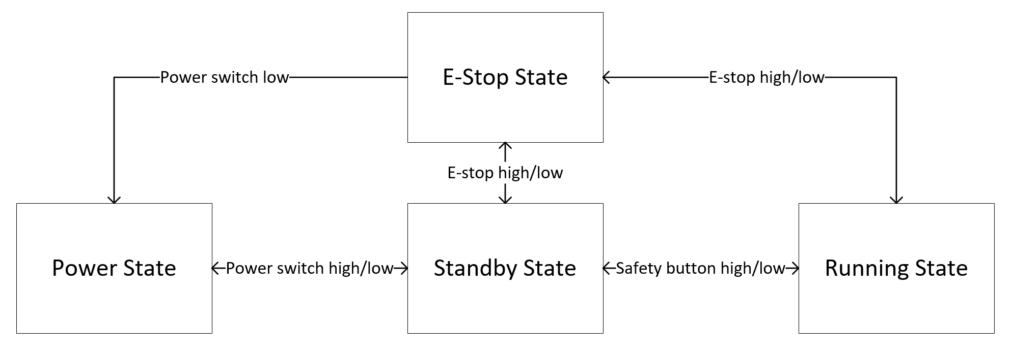

Figure 4‑1 - Software State Diagram

Each system state is described below:

* Power State – The system is powered off and no operations may be performed.
* Standby State – The default state of the system. The system is powered on, but no operations may be performed until the operator depresses the safety button.
* Running State – The system is enabled to perform all rotation operations. It will stay in this state if the safety button remains depressed or the E-stop is not activated.
* E-Stop State – The system is shifted to E-stop state when the E-stop button is activated. In the E-stop state, system operations cannot be performed until the E-stop button is deactivated.

It is important to note that while the Standby and E-stop state perform the same function of preventing rotation operations, the Standby state applies a software lock to the motors while the E-stop state cuts power to the motor, applying a hardware lock on the system.

## System Operations

The system takes user input from the Control Panel and the Control Box and it provides system status from the Control Panel.

### User Inputs

Each form of user input is described below. See FIGURE1 and FIGURE2 for mockups of the inputs on the Control Box and Control Panel, respectively:

Control Box:

* **Power Switch** – located on the front of the box. Used to power on and off the system.
* **Calibration Button** – located on the front of the box. Used to set a home position in the system. This stores the current angular position of the system in the microprocessor, which is utilized by the home button on the Control Panel. Overwrites the previous home position when pressed.

Control Panel:

* **Rotate CW Button** – located on the front of the panel. Rotates the system in the clockwise direction around the horizontal axis. FIGURE illustrates how the rotation direction is determined.
* **Rotate CCW Button** – located on the front of the panel. Rotates the system in the counterclockwise direction.
* **Rotate 45° CW Button** – located on the front of the panel. Rotates the system 45° in the clockwise direction.
* **Rotate 45° CCW Button** – located on the front of the panel. Rotates the system 45° in the counterclockwise direction.
* **Home Button** – located on the front of the panel. Rotates the system to the home angular position.
* **Safety Button** – located on the front of the panel. The safety button must be depressed while performing rotating operations and shifts the system to the Running State.
* **Stop/Reset Button** – located on the front of the panel. Pressing the button stops the system from rotating during the running state. When in the E-stop state, pressing this button puts the system back into the Standby state.

### Operator Feedback

The system provides the operator with feedback through an LED and buzzer, located on the front of the Control Panel. The LED is used to depict the current state that the system is in, while the buzzer is used to alert anyone in vicinity of the system that it is rotating or experiencing an error.

A description of the LED and buzzer’s behaviour for each state is described below in Table 4‑1:

|  |  |  |  |
| --- | --- | --- | --- |
| State | LED Behaviour | Buzzer Behaviour | Comments |
| Power | Off | Off |  |
| Standby | Solid Amber | Off |  |
| Running | Blinking Green | Long Beeping | Only beeps while the table is rotating. Beeps 2s on/off continuously. |
| E-Stop | Blinking Red | Short Beeping | Beeps 0.5s on/off continuously. |
| Reset Required | Solid Red | Medium Beeping | Beeps 1s on/off continuously. |

Table 4‑1 - Behaviour of LED and Buzzer for each System State

In addition, the buzzer will be activated in specific patterns for situations where the system experiences an error. Examples of errors include if the attached load is too heavy or if the system has rotated less/more than expected. The buzzer patterns are TBD.

### Home Function

The system features a home position function, which allows the operator to quickly recall a home angular position. The home position is stored on the microcontroller and updated each time the calibration button on the control box is pressed. The purpose of this function is to remove the need for the operator to carefully set the system to a commonly used angular position by allowing the operator to simply press a recall button on the control box instead. The safety button must be depressed first to use this function.

## E-Stop Functionality

The E-stop of the system performs a category 0 stop as defined by the NFPA 79 standard. When an E-stop is engaged from the Control Panel, the E-Stop Circuit immediately stops 208 VAC power from reaching the Rotator subsystem, stopping all rotation operations immediately. However, power is still supplied to the rest of the system which comprises the Control Box and Control Panel. The E-Stop Circuit notifies the microcontroller that an E-stop is active, which then will notify the operator that an E-stop is on using the LED and buzzer on the Control Panel (see Table 4‑1).

To reactivate the system after an E-stop, the E-stop button must first be disengaged. Once the Control Panel indicates that the system requires a reset (Table 4‑1), the operator may press the Stop/Reset button on the Control Panel to re-enable system operations.